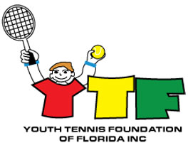

GUIDELINES FOR
JACK BLAIR COLLEGE TENNIS ACADEMY AWARD PROGRAM
www.YTF-FL.org

- High School Varsity Tennis Player or USTA Junior tournament level player

- Positive attitude

- 15-18 years old

A full expenses paid award will be provided to a selected boy and girl to the Ed Krass Tennis Camp at the venue to be used for the current year.

Please submit application to:

Youth Tennis Foundation
c/o Pierce Kelley
- O. Box 452
Fort White, FL 32038
OR
Email piercekelley@att.net

Deadline to submit application: December 1 of current year
Winner to be chosen by YTF board
Winner will be notified by Pierce Kelley

Application Form
Jack Blair College Tennis Academy Scholarship
www.YTF-FL.org

NAME:

ADDRESS:

PHONE NUMBER:

EMAIL ADDRESS:

REFERENCE CONTACT INFO:

Why do you feel you qualify for the Jack Blair College Tennis Academy Scholarship?

(attach additional sheet if necessary)

Recommendation from reference:

(attach additional sheet if necessary)

Please send completed application to

Youth Tennis Foundation
c/o Pierce Kelley
- O. Box 452
Fort White, FL 32038
OR
Email piercekelley@att.net

Visit YTF website, www.YTF-FL.org, for more information

